Document:

Direct G-Code Programming of the Prusa I3 MK3S for Controlled Motion Experiments
December 1st, 2025
Authors: Alex Zheng, Silas Ifeanyi

Table Of Contents

Direct G-Code Programming of the Prusa I3 MK3S for Controlled Motion Experiments 1
Table Of Contents 2
Technical Documentation 3
1. Overview and Purpose 3
2. Required Hardware & Software 3
Hardware 3
Software 4
3. System Architecture and Data Flow 4
Step 1 — User Input (Python UI) 5
Step 2 — Preprocessing 5
Step 3 — Send to Printer (Pronterface) 5
Step 4 — Mechanical Execution 6
4. The G-Code Structure Used in This Project 6
4.1 Motion-Only Command Set 6
5. Motion Pattern Types Supported 6
5.1 X-Axis Raster Scan 7
5.2 Y-Axis Raster Scan 7
5.3 Serpentine (Back-and-Forth) Scan 7
5.4 Arbitrary Patterns 7
6. Why We Use Direct G-Code (PI-Level Explanation) 8
6.1 Avoiding Prusa Firmware Self-Checks 8
6.2 Maximum Control for Research 8
6.3 Integration with Robotics Research 8
7. Summary of Key Constraints in Our Implementation 9
8. Example Minimal G-Code Snippet 9
9. Safety Notes 9
10. Future Work 10

Technical Documentation

1. Overview and Purpose
This document describes how to directly control the Prusa I3 MK3S motion system using G-code commands for thin-film imaging applications using a python UI.
Unlike normal 3D printing workflows, this pipeline bypasses homing, calibration, extrusion, and safety checks, enabling precise motion without requiring the standard printing toolchain or slicer.
This approach is essential because our MK3S printer has been physically modified (e.g., sensor changes, removed extruder, instrumentation added). These modifications cause the printer’s built-in self-checks to fail. Therefore, we operate the printer as a Cartesian robotic stage using only motion-related commands.
The workflow supports:
- Absolute Cartesian moves (X/Y/Z)
  - Raster scan generation (X-scan, Y-scan, serpentine)
- Adjustable speed, jerk, acceleration
- Boundary checking via a Python preprocessing system
- 100% manual execution of motion patterns in Pronterface

2. Required Hardware & Software

Hardware
- Prusa I3 MK3S 3D printer
  - Uses the Einsy RAMBo (MK3/S/+) microcontroller
- Computer/Laptop with a USB port
- USB-A (PC side) → USB-B (printer side) cable
  - Required for direct serial communication

Software

2.1 Pronterface (Printrun)
- Download: https://github.com/kliment/Printrun/releases/tag/printrun-2.2.0
- Purpose:
  - Provides a manual serial interface to the printer
  - Allows sending G-code line-by-line
  - Bypasses Prusa firmware’s self-check workflow
- Why Pronterface?
  - Very easy to use
  - Sends raw G-code without enforcing extrusion/homing
  - Provides command log and error logging
  - Provides a preview of the scan pattern

2.2 Python Code (Virtual Environment)
- Contains the custom motion-parameter UI / preprocessor
- Purpose:
  - Allows the user to choose:
    - Motion type (X-raster, Y-raster, serpentine/back-and-forth)
    - Initial location (X₀, Y₀, Z₀))
    - Speed (F-value)
    - Acceleration, Jerk
    - Physical Bounds (length, width)
    - Number of spectrometry + imaging timestamps
  - Automatically generates G-code for the selected pattern
  - Checks boundary conditions (printer limits)
  - Outputs a G-code file (.txt) that is loaded into Pronterface

3. Procedure

Step 1 — User Input (Python UI): Front end
User selects:
- Motion type
  - Raster, back-and-forth (The back and forth continues for 20000 iterations).
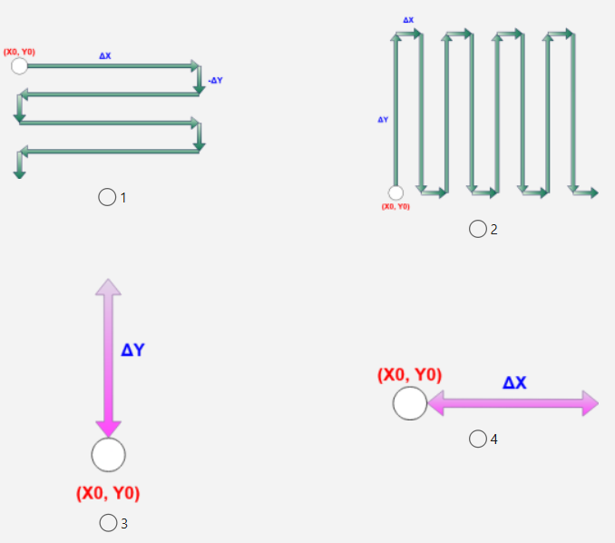
- Raster parameters
  - Initial location, scan dimensions, bounds
- Speed, acceleration, jerk
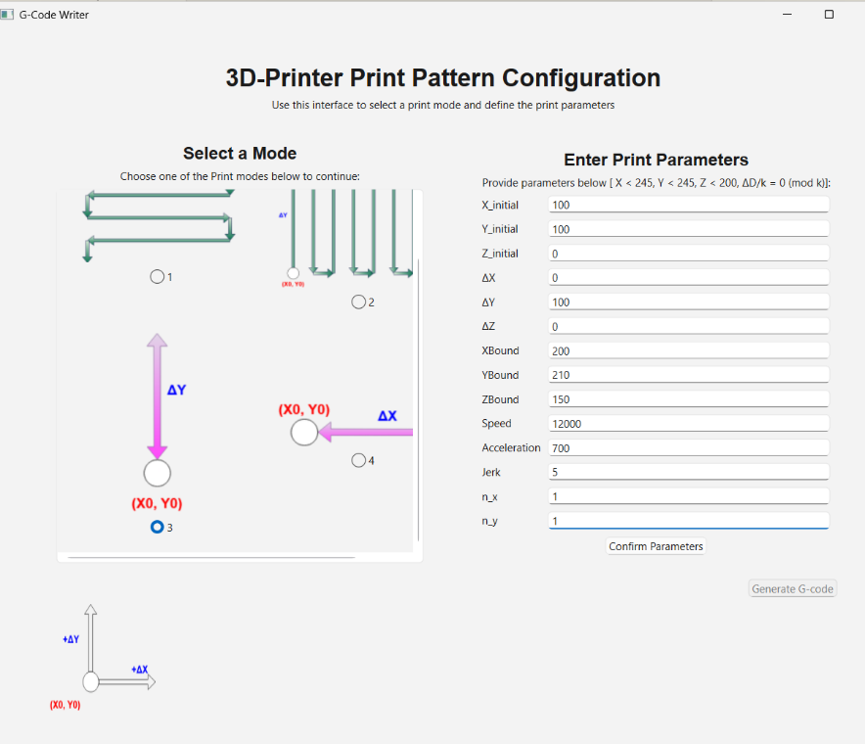

Step 2 — Preprocessing (Internal): Backend
Python:
- Validates inputs
- Ensures moves remain within X/Y bounds
- Generates a fully deterministic G-code file
- Embeds motion parameters (F-speed, M204 acceleration, M205 jerk if needed)
- Ensures absolute positioning (G90)

Step 3 — Send to Printer (Pronterface)
- Establish serial connection (via USB-A→B) to the Prusa MK3S 3D-printer
- Load the generated .txt (G-code) file into Pronterface and verify the logs that it shows that the print is ready and not erroring.
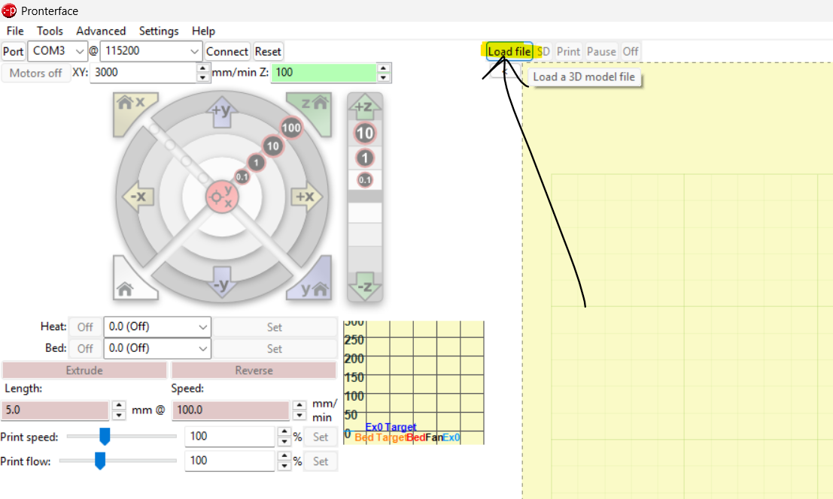
- Press “Print”. Note that the printer may do a non-destructive pre-calibration movement, it is not an error.
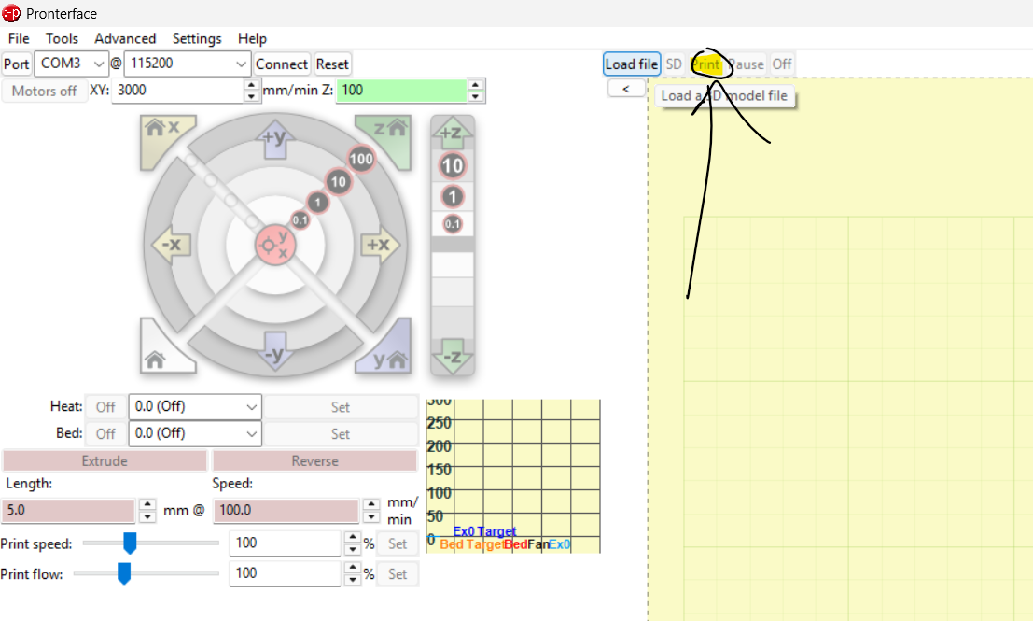
- Observe motion in real time. Check logs to see if erroring. If the movement is offset, it means that the 3D printer is not properly homed. This can be solved by resetting homing parameters (to 0) in printer settings or restarting the printer and Pronterface application.

3.1 — Mechanical Execution (Automatic)
The MK3S executes G-code motion as a 3-axis Cartesian robot without using:
- Extrusion
- Homing
- Z-probe
- Filament/bed level sensors
- Heatbed/nozzle
If we use normal Prusa workflows, the firmware refuses to operate. Direct serial communication bypasses this issue.

3. *Experimental Procedure*
- The maximum Speed is 12000 [mm/s] (max speed). Acceleration and Jerk should be kept to 700 [mm/s/s] and 5 [mm/s] (test conditions and verified). These values have been computed to be optimal.
  - Never issue high acceleration moves without validating mechanical limits.
- The X, Y, Z bounds should be kept within 200, 210, 150 [mm], respectively. This can be exceeded but requires further testing.
- When inserting the spectrometer into the spectrometer insertion hole, make sure that the distance between the spectrometer tip and the sample is roughly around 1 cm (thumbnail length).
- Alternatively, the top end of the spectrometer should be inserted until the groove of the spectrometer top end meets the edge of the insertion hole.
This is a source of error.
2. The spectrometer wiring should be stationary during measuring to avoid noise.
3. Although the printer parameters are variable, the recommended parameters (for everything except speed, as done in prev experiments) are:
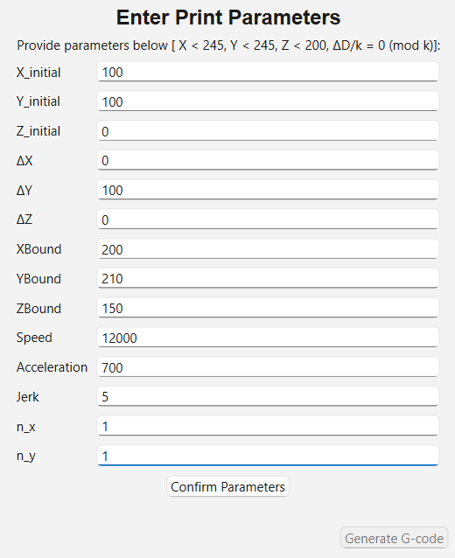

4. The G-Code Structure Used in This Project

4.1 Motion-Only Command Set
We intentionally restrict ourselves to:
- G90 – absolute positioning
- G0/G1 – linear movement
- F – feedrate (speed) [mm/min]
- M204 – set acceleration [m/s/s]
- M205 – set ‘jerk’/junction speed limits [mm/s]
No:
- G28 (homing)
- Extrusion (E commands)
- Temperature commands (M104, M109, M140, M190)
- Auto-bed-leveling
- Filament checks
- Self-diagnostics
This ensures full compatibility with our customized printer hardware.

8. Example Minimal G-Code Snippet
G90 ; absolute positioning
M204 S300 ; set acceleration
M205 X10 Y10 ; jerk limits

G1 X0 Y0 F3000 ; move to start
G1 X100 Y0 ; first scan line
G1 X100 Y10
G1 X0 Y10

Serial communication start/stop signalling not implemented.

Timer Synchronization
An algorithm was created to synchronize printer motion with spectrometry/imaging. The idea is to divide a raster scan pattern in n_x and n_y points of equal distance, such that it is at these points, the spectrometer/camera captures data. Since the scan pattern’s information is fully defined, we can use kinematics: speed, acceleration, and jerk, to compute the timestamps at which the camera/spectrometer should take the image. This algorithm is implemented only for the raster scan pattern (below) and is described below and implemented in code, requiring further work and optimization.
  - Note that Jerk is actually “junction deviation speed”, the speed at which the printer head approaches a corner.
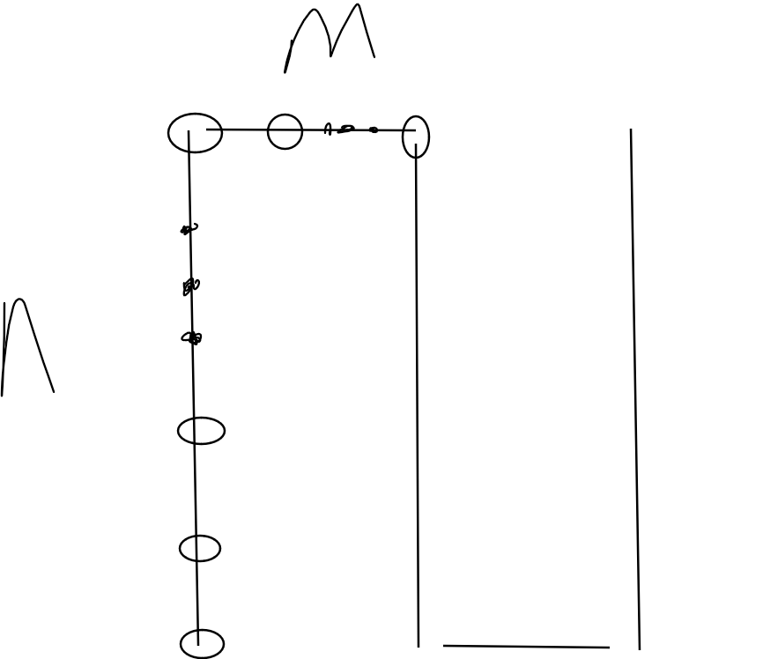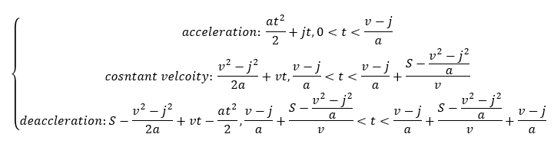
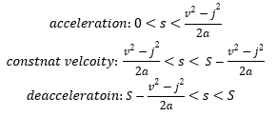
We know the locations of the points to image, thus the displacement. Then we use the mapping function to take displacement to time, for all points, generating the timestamp vector!
Important: This algorithm assumes that the scan is long enough in each direction such that constant velocity is reached for each linear movement.

9. Future Work
- Fully implement the synchronization of the timer with the printing movement so that the locations of desired imaging or spectrometry can be deterministically mapped to timestamps that the imaging or spectrometry take place.
- Implementation of a timer thread in the frontend UI that shows the duration of the print.
- Implementation of serial communication between code and Printer that indicates when a print is signalled to start and stop, using M118 command.
- Implementation of a speedometer on the frontend UI that shows the current speed. This can be implemented using the equations above for v.

